Project Title
Deployment of a Static Website Using Amazon S3, CloudFront, Route 53 and AWS Certificate Manager
By
Angel

Step 1
Created an Amazon S3 bucket to store the files for my static website and also uploaded my static website files into the S3 bucket.
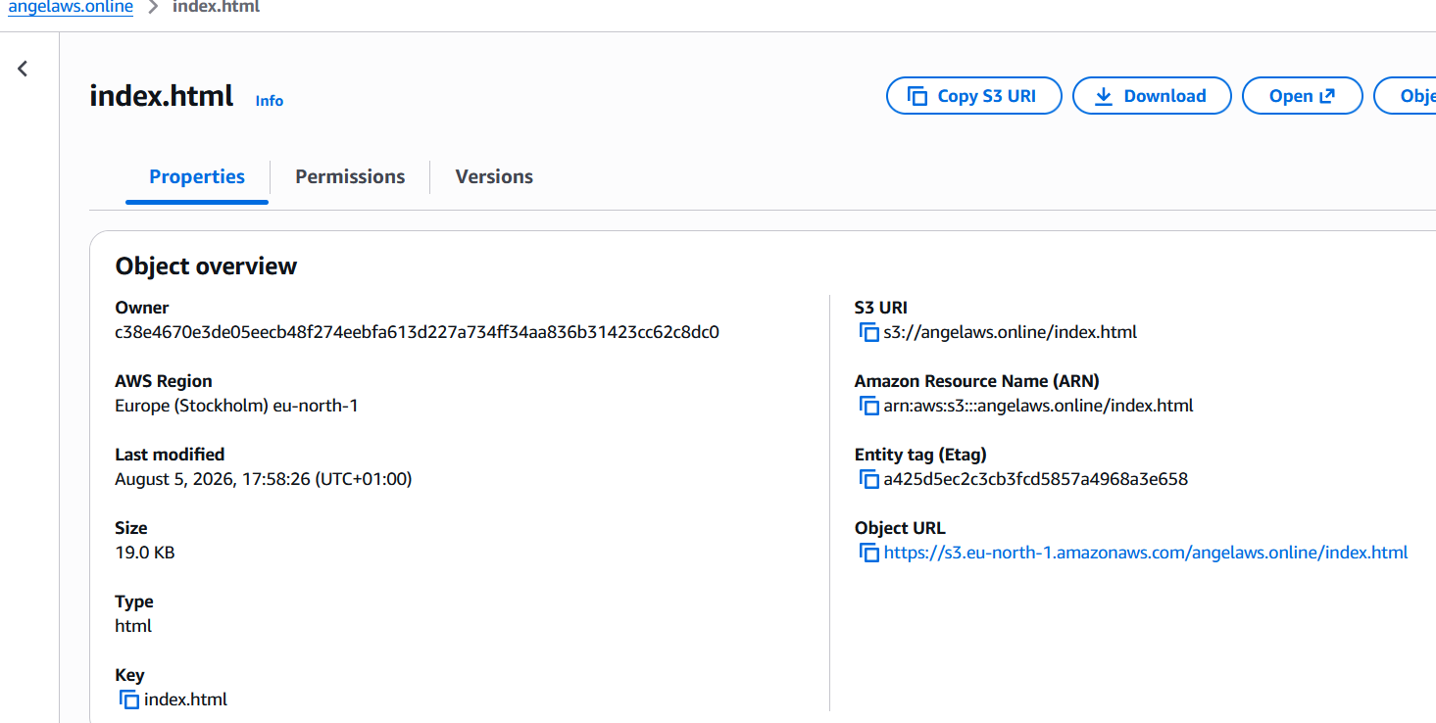

Step 2
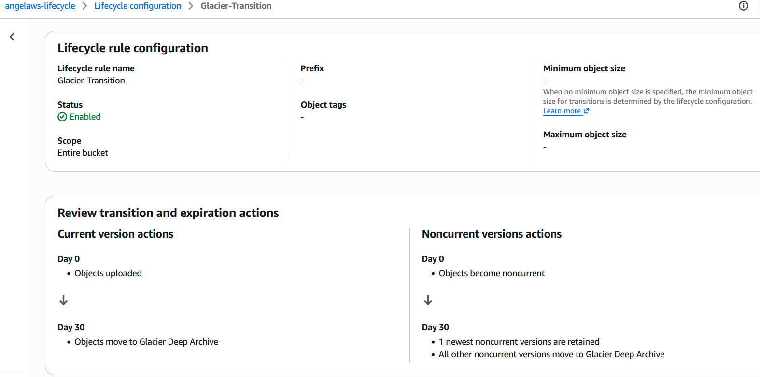

Step 3
Configured S3 public access and also added a bucket policy that allows public read access to objects in the bucket.
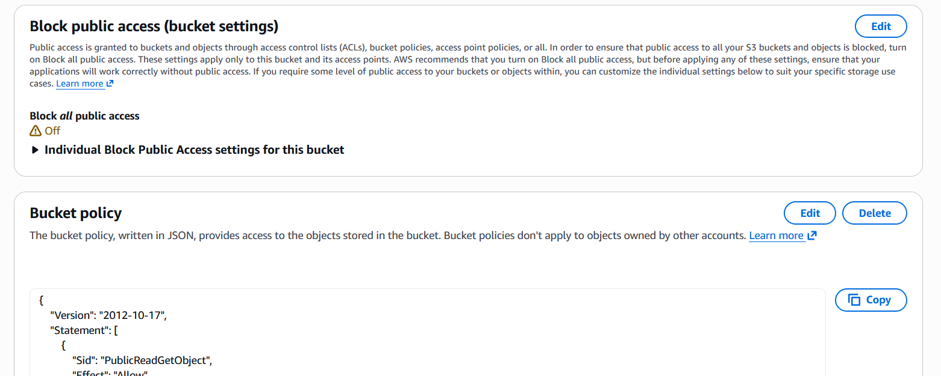

Step 4
Created/configured a public hosted zone for angelaws.online in Amazon Route 53.
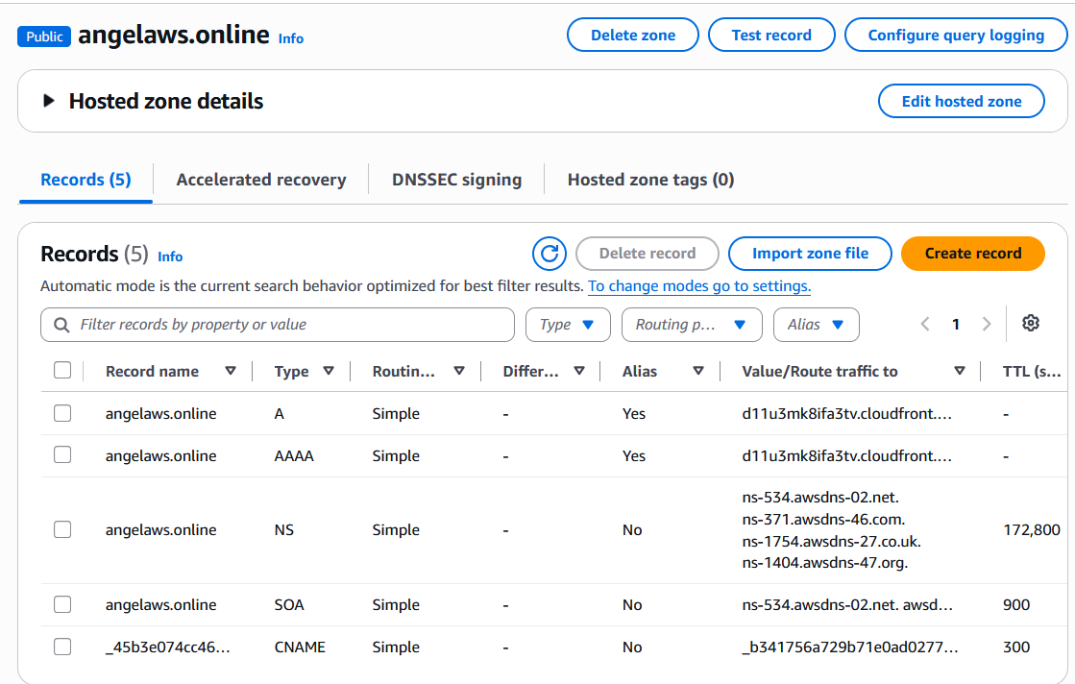
Step 5
I updated the nameservers for angelaws.online in Namecheap to the Amazon Route 53 nameservers.
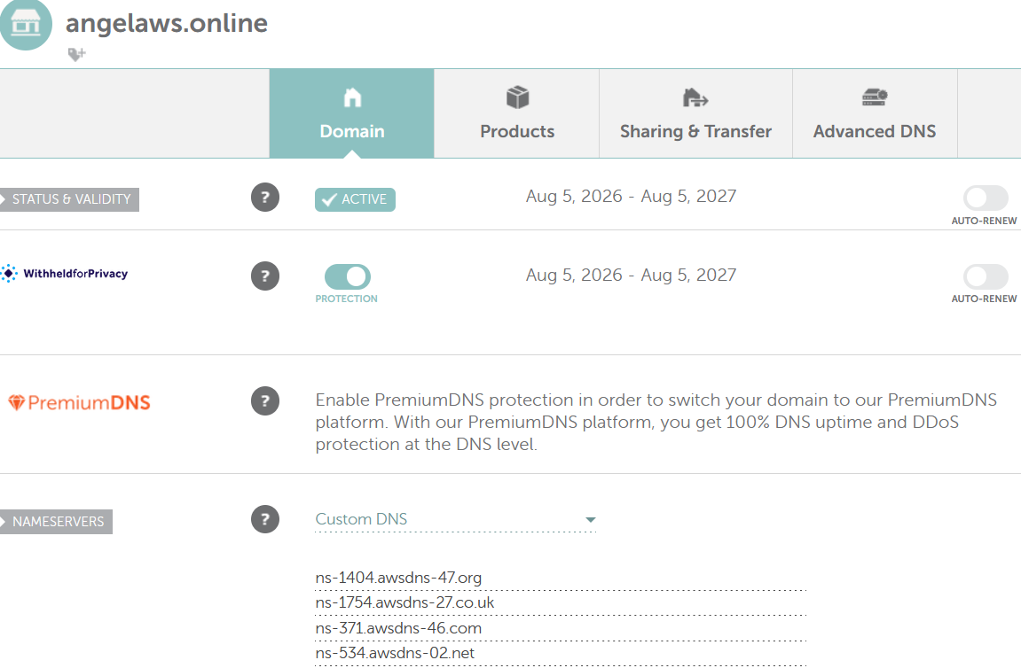

Step 6
I requested an SSL certificate for angelaws.online using AWS Certificate Manager (ACM).
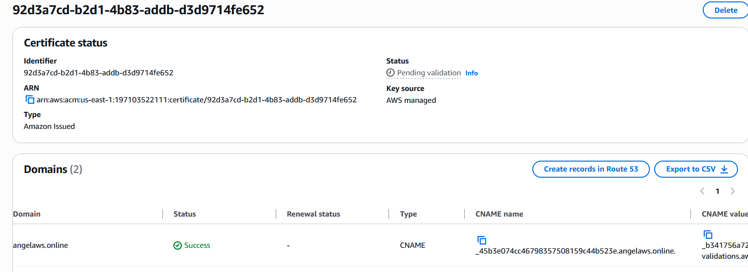

Step 7
Created a CloudFront distribution
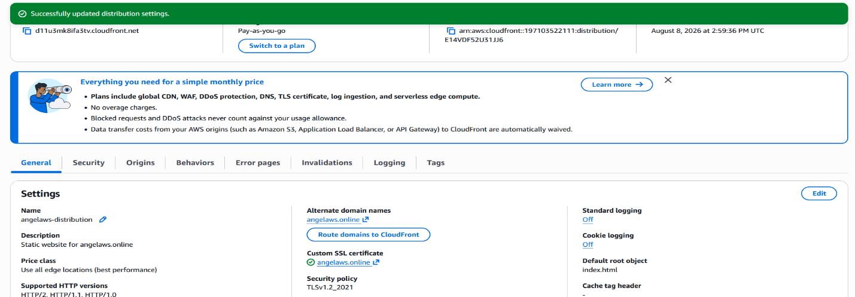

Step 8
I configured the Route 53 DNS records
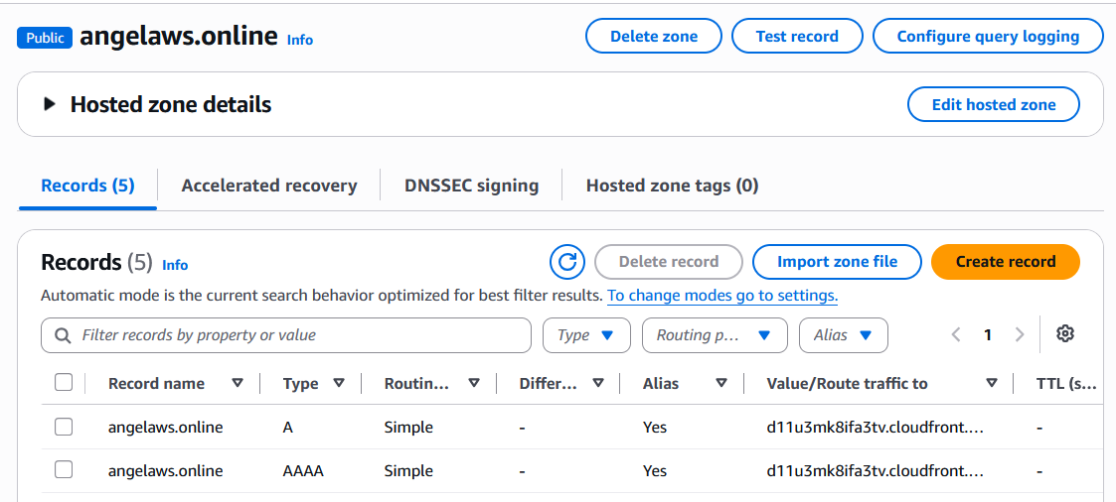
Step 9
The website was successfully deployed using Amazon S3, CloudFront, Route 53 and AWS Certificate Manager.
https://angelaws.online
